**Lab no: 7 – STRINGS**

Write C programs without using STRING-HANDLING functions for the Questions 1 & 2.

Q1. Count the number of words in a sentence.

**Program:**

//Counting the number of words in a given sentence.

#include <stdio.h>

#include <stdlib.h>

int main()

{

printf("Name : MANOJ M MALLYA\n\n");

const int len=100;

char sent[len];

int i,count=1;//no.of words in a sentence = no.of spaces encountered + 1

printf("Enter your sentence : ");

gets(sent);

for(i=0;sent[i]!='\0';i++)

{

if ((sent[i]==' ') && (sent[i+1]!=' '))

{

count++;

}

}

printf("\n\nThe number of words in the given sentence = %d\n\n",count);

return 0;

}

**Output:**

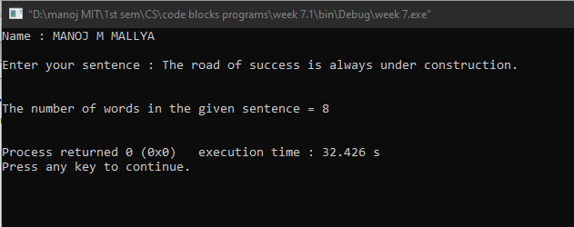

Q2. Input a string and toggle the case of every character in the input string. Ex: INPUT : aBcDe

OUTPUT : AbCdE

**Program:**

//Toggling the case of every character in the input string.

#include <stdio.h>

#include <stdlib.h>

int main()

{

printf("Name : MANOJ M MALLYA\n\n");

char str[200];

int i=0;

printf("Enter your string : ");

gets(str);

while(str[i]!='\0')

{

if(str[i]>='A'&&str[i]<='Z')//ASCII value of [A-Z]=[65,90]

{

str[i]=str[i]+32;

}

else if(str[i]>='a'&&str[i]<='z')//ASCII value of [a-z]=[97,122]

{

str[i]=str[i]-32;

}

i++;

}

printf("\nToggled string : ");

puts(str);

return 0;

}

**Output:**

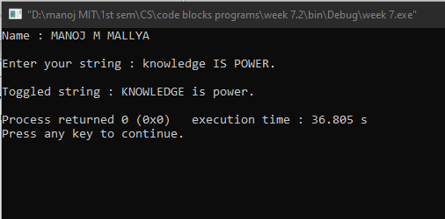

Q3. Arrange ‘n’ names in alphabetical order (hint: use string handling function-strcpy)

**Program:**

//Arranging ‘n’ names in alphabetical order.

#include <stdio.h>

#include <stdlib.h>

#include <string.h>

int main()

{

printf("Name : MANOJ M MALLYA\n\n");

char a[50][20],temp[20];

int i,j,n;

printf("Enter the number of names : ");

scanf("%d",&n);

printf("\nEnter the names : \n");

fflush(stdin);

for(i=0;i<n;i++)//getting the names

{

gets(a[i]);

}

for(i=0;i<(n-1);i++)//arrangement

{

for(j=i+1;j<n;j++)

{

if(strcmp (a[i],a[j])>0)//comparing and swapping if necessary

{

strcpy(temp,a[i]);

strcpy(a[i],a[j]);

strcpy(a[j],temp);

}

}

}

printf("\nThe alphabetical order is : \n");

for(i=0;i<n;i++)

puts(a[i]);

return 0;

}

**Output:**

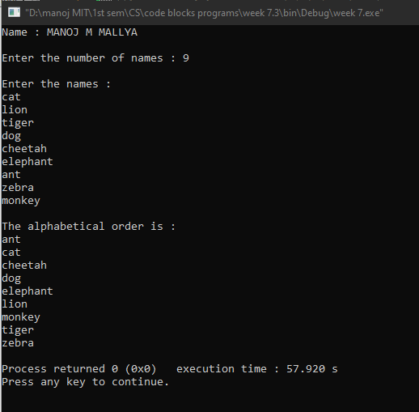

**********

**Lab no: 8 – MODULAR PROGRAMMING – FUNCTIONS**

Q4. Write a function Largest to find the maximum of a given list of numbers. Also write a main program to read N numbers and find the largest among them using this function.

**Program:**

//Finding the largest number in a list using functions.

#include <stdio.h>

#include <stdlib.h>

int Largest(int x[],int);//prototype

//function for finding the largest element.

int Largest(int x[100],int s)

{

int m,i;

m=x[0];

for(i=0;i<s;i++)

{

if(x[i]>m)

{

m=x[i];

}

}

return(m);

}

int main()

{

printf("Name : MANOJ M MALLYA\n\n");

int a[100],N,i;

printf("Enter the number of numbers : ");

scanf("%d",&N);

printf("\nEnter your numbers : \n");

for(i=0; i<N; i++)

{

scanf("%d",&a[i]);

}

printf("\nThe maximum element in the given array is %d.\n",Largest(a,N));

return 0;

}

**Output:**

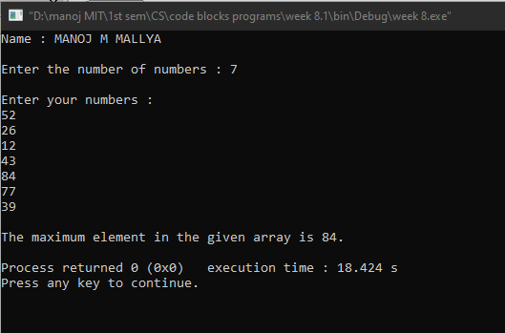

Q5. Write a function CornerSum which takes as a parameter, no. of rows and no. of columns of a matrix and returns the sum of the elements in the four corners of the matrix. Write a main function to test the function.

**Program:**

//Finding the sum of corner elements of a 2D matrix using functions.

#include <stdio.h>

#include <stdlib.h>

int CornerSum(int x[][100],int p,int q);//prototype

int main()

{

printf("Name : MANOJ M MALLYA\n\n");

int a[100][100],m,n,i,j;

printf("Enter the dimension of the matrix : \n");

scanf("%d %d",&m,&n);//getting the dimensions of the matrix

printf("\nFill the matrix with your numbers : \n");

for(i=0;i<m;i++)//getting the matrix

{

for(j=0;j<n;j++)

{

scanf("%d",&a[i][j]);

}

}

printf("\nThe matrix : \n");

for(i=0;i<m;i++)//printing the matrix

{

for(j=0;j<n;j++)

{

printf("%4d",a[i][j]);

}

printf("\n");

}

printf("\nThe corner sum of the matrix = %d.\n",CornerSum(a,m,n));

return 0;

}

int CornerSum(int x[][100],int p,int q)

{

int sum=0;

//computing the corner element's sum

for(int i=0;i<p;i++)

{

for(int j=0;j<q;j++)

{

if((i==0||i==(p-1)) && (j==0||j==(q-1)))

{

sum+=x[i][j];

}

}

}

return(sum);

}

**Output:**



